VGG MODEL

Data Used

Here we are using augmented data set which we made from our original data set

It contains Training and Validation data

Training Data has 12319 images for both tanks and non tanks

Validation Data has 3503 images for both tanks and non-tanks

DATA DIMENSION

Images are in three channels (RGB)

Dimension of images are 512\*512\*3

Images are than rescaled with (rescale = 1/255) function of keras Datagenerator

VGG 16 MODEL

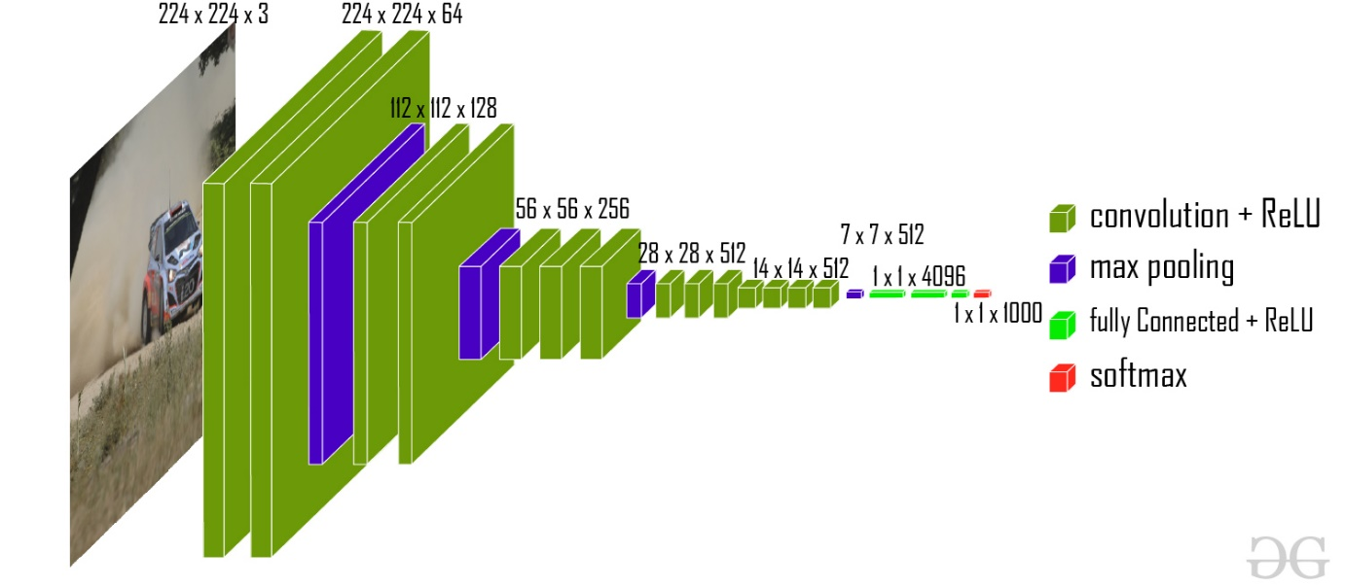

DENSE LAYER

prediction = Dense(len(folders),activation='softmax')(x)

model = Model(inputs= vgg.input,outputs=prediction)

PARAMETERS FOR TRAINING

1. Optimizer : Adam with learning rate = 0.001
2. Loss Function is Binary Cross Entropy
3. Trained for 5 epochs

RESULT

